**Shapley - 27 Features (FI 0.50)**

Considering Shapley Feature importance values ≥ 0.50.

**Features:** FC3, Fz, F7, FT7, T4, T3, Fp2, Fp1, TP7, CP3, F4, F8, F3, O2, O1, T6, Oz, FT8, PZ, T5, FCZ, C4, CP4, TP8, FC4, C3, P3

**Machine learning evaluation using 27 Features with Feature Importance ≥ 0.50.**

|  |  |  |  |  |  |  |
| --- | --- | --- | --- | --- | --- | --- |
| Model | Accuracy | Precision | Recall | F1-score | AUC-ROC | Training Times (s) |
| KNN | 0.998603 | 0.999149 | 0.998054 | 0.998601 | 0.998602 | 0.06 |
| Random Forest | 0.992427 | 0.996415 | 0.988404 | 0.992393 | 0.992425 | 613.76 |
| XGBoost | 0.956430 | 0.968981 | 0.943013 | 0.955821 | 0.956425 | 6.58 |
| Decision Tree | 0.922262 | 0.923979 | 0.920169 | 0.922070 | 0.922261 | 50.91 |
| Extra Trees | 0.995692 | 0.998381 | 0.992991 | 0.995679 | 0.995691 | 151.06 |

**Table:** Machine learning evaluation using 27 Features with Feature Importance ≥ 0.50.

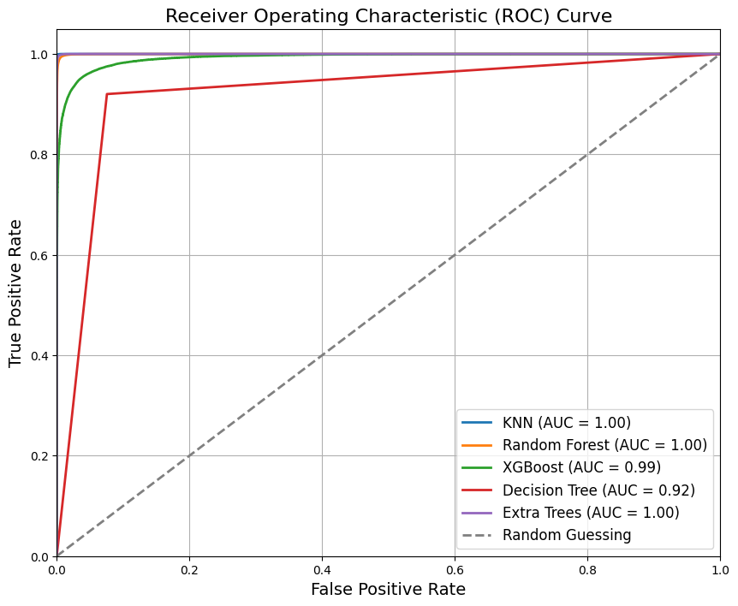

**Figure:** ROC Curve for Machine Learning Results using 27 Features with Feature Importance ≥ 0.50.

**Classification Reports - 27 Features**

**KNN:**

**precision recall f1-score support**

0 1.00 1.00 1.00 77676

1 1.00 1.00 1.00 77614

accuracy 1.00 155290

macro avg 1.00 1.00 1.00 155290

weighted avg 1.00 1.00 1.00 155290

**Random Forest:**

**precision recall f1-score support**

0 0.99 1.00 0.99 77676

1 1.00 0.99 0.99 77614

accuracy 0.99 155290

macro avg 0.99 0.99 0.99 155290

weighted avg 0.99 0.99 0.99 155290

**XGBoost:**

**precision recall f1-score support**

0 0.94 0.97 0.96 77676

1 0.97 0.94 0.96 77614

accuracy 0.96 155290

macro avg 0.96 0.96 0.96 155290

weighted avg 0.96 0.96 0.96 155290

**Decision Tree:**

**precision recall f1-score support**

0 0.92 0.92 0.92 77676

1 0.92 0.92 0.92 77614

accuracy 0.92 155290

macro avg 0.92 0.92 0.92 155290

weighted avg 0.92 0.92 0.92 155290

**Extra Trees:**

**precision recall f1-score support**

0 0.99 1.00 1.00 77676

1 1.00 0.99 1.00 77614

accuracy 1.00 155290

macro avg 1.00 1.00 1.00 155290

weighted avg 1.00 1.00 1.00 155290

**Confusion Matrix - 27 Features**

